

Title: Real-Time Augmented Reality Overlay for Advanced Data Visualization
Internship Assignment
Project Plan Of Internship
Name
Soufiane Kissami
r0976650
Bachelor's degree in Computer Science
field AI

Academic year 2023-2024
Campus Geel, Kleinhoefstraat 4, BE-2440 Geel

Project Plan for Internship Project

AR-Enhanced Material Measurement: Real-Time Data Overlay on Quality Control Machine Video Stream

Project Overview
This project aims to develop an Augmented Reality (AR) system that visually represents basis weight measurement data on a live video feed from a high-end SICK camera. The system will utilize ArUco markers for edge detection, homography transformation for coordinate mapping, and overlay AR generated color-map images onto the live feed. This document outlines the project plan, including development stages, key milestones, and deliverables.
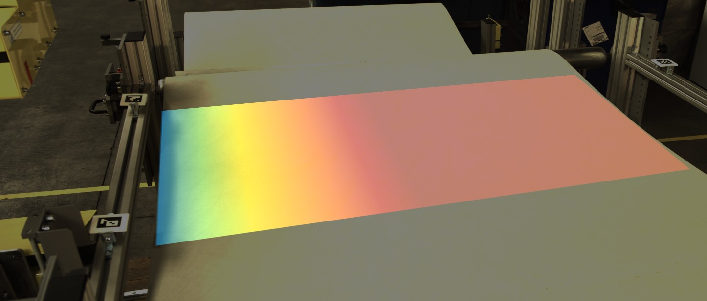

Company Background
Hammer-IMS, based in Herk-de-Stad, Belgium, is a high-tech machine builder specializing in industrial quality and process control solutions. The company offers contactless measurement systems for thickness, basis-weight, and anomaly detection in flat structures on production lines. Hammer-IMS bridges the gap between technology and user-friendly interfaces, providing easy-to-understand, color-spectrum-based results.

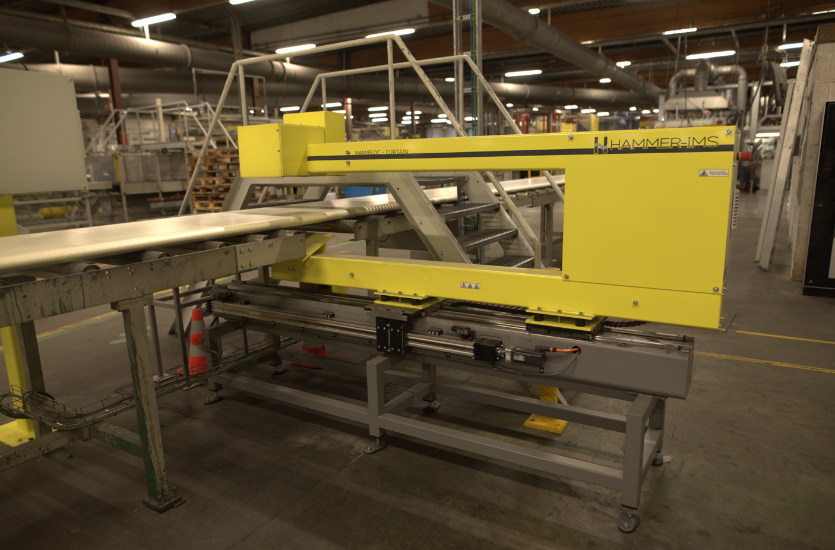

Business Case

Problem Statement
In the manufacturing industry, accurate and real-time monitoring of basis weight and material thickness is crucial for quality control and production efficiency. Traditional methods, such as processing CSV files, spreadsheets, and graphs, are complex and time-consuming, leading to potential errors and delays.

Solution
The proposed AR system visually represents measurement data using color-maps, where the color spectrum identifies data values. This modern AR approach simplifies data interpretation, making it easier than processing CSV files, spreadsheets, or graphs. It bridges the gap between machine operators and technology, providing a user-friendly interface. Additionally, the color-coded system helps manufacturers quickly and efficiently understand the measurement results, enhancing overall user experience and decision-making.

Benefits
Benefit | Description
Improved Accuracy and Efficiency | Real-time data monitoring reduces errors and allows for immediate corrective actions. Automation of measurement and data overlay saves time and reduces manual labor.
Enhanced User Experience | The AR system provides a clear and intuitive way to visualize measurement data. Color-coded color-map overlays simplify understanding measurement variations.
Better Decision-Making | Immediate access to real-time data enables quicker decision-making. Facilitates proactive maintenance and process adjustments, minimizing downtime and waste.
Customer Satisfaction | Enhances transparency and communication with customers through visual data representation. Improves customer trust and satisfaction with easier-to-understand results.
Competitive Advantage | Positions Hammer-IMS as a leader in industrial quality control technology with innovative AR solutions. Demonstrates commitment to leveraging advanced technologies for industrial process improvement.

Return on Investment (ROI)
ROI Component | Description
Cost Savings | Reduced labor costs and minimized errors lead to significant savings.
Increased Productivity | Enhanced efficiency and faster decision-making boost overall productivity.
Market Differentiation | The innovative AR solution can showcase how technologically advanced Hammer-IMS is.

Key Words and Meanings
Augmented Reality (AR) | A technology that overlays digital information on the real-world environment.
ArUco Markers | Fiducial markers that are used to determine the pose of a camera. In my case, I use them to set the edges of the material I am working with.
Homography Transformation | A method that maps points from one plane to another using a matrix transformation.
Basis Weight | The weight of material per unit area, used in quality control processes.
SICK Camera | High-end industrial camera used for capturing live video feeds in manufacturing environments.
Harvester Library | A Python library used for interfacing with industrial cameras and acquiring images.
Color-map | A visual representation of data values using a color spectrum.
Real-time Data | The process of continuously tracking data in real-time.

Project Objectives
Objective | Description
Integrate SICK Camera with Harvester | Connect and configure the SICK camera using the Harvester library for live video capture.
ArUco Marker Detection | Implement ArUco marker detection to identify and track material edges.
Homography Transformation | Apply homography transformation to map marker coordinates to a fixed reference system.
Color-map Generation and Overlay | Generate color-map images based on basis weight data and overlay these on the live feed.
Real-time Update Mechanism | Ensure color-map images update in real-time with new measurement data.

Project Phases
Phase | Tasks | Milestones
Initialization and Setup | Research and planning. Environment setup (NumPy, OpenCV, Matplotlib, Pandas, Harvester). Camera integration. | Development environment set up. SICK camera integrated and capturing live feed.
ArUco Marker Detection | Study ArUco marker detection. Implement marker detection code. Identify material edges. | ArUco markers detected in live feed. Material edges identified.
Homography Transformation | Study homography principles. Implement coordinate mapping code. Validate transformation accuracy. | Homography transformation implemented. Accurate coordinate mapping achieved.
Color-map Generation and Overlay | Generate color-map images. Monitor measurement data. Overlay images onto live feed. | Color-map images generated. Images overlaid on live feed.
Real-time Update Mechanism | Implement real-time data monitoring. Optimize system performance. Conduct testing and validation. | Real-time updates implemented. Real-time overlaid augmented reality color-maps update and regenerate simultaneously as results from data monitoring are updated.

Key Deliverables
Deliverable | Description
Code Base | Fully functional AR system code.
Documentation | Summary report, Project plan report, evidence of realization report, and reflection report.
Demo Video | Video showcasing the AR system in action with real-time color-map updates.
Project Report | Final report summarizing objectives, methodology, challenges, and results.

Project Timeline
Phase | Start Date | End Date
Initialization and Setup | Week 1 | Week 2
ArUco Marker Detection | Week 3 | Week 4
Homography Transformation | Week 5 | Week 6
Color-map Generation and Overlay | Week 7 | Week 8
Real-time Update Mechanism | Week 9 | Week 10
Testing and Validation | Week 11 | Week 12
Final Deliverables | Week 13 | Week 14

Risk Management

Potential Risks and Mitigation Strategies
Potential Risk | Mitigation Strategy
Technical Challenges | Regular testing and validation. Continuous code optimization.
Performance Issues | Implementing fallback mechanisms for data accuracy.
Data Accuracy | Regular testing and validation.

Communication and Follow-up
Aspect | Details
Reporting Frequency | Daily progress meetings
Reporting Form | Weekly written reports and live demonstrations
Project Management Tools | Regular word files for task tracking and progress management
Team and Responsibilities | Intern: Primary development and implementation. Maarten De Groof: Project mentor, daily guidance and feedback. Tom Redant and Joost Poelmans: Occasional progress checks and feedback.

Conclusion
This project plan outlines a structured approach for developing the AR measurement system. By following this plan, systematic progress and successful completion of the project objectives will be ensured, enhancing data visualization and interaction to view measurement results in an innovative and simple approach.

